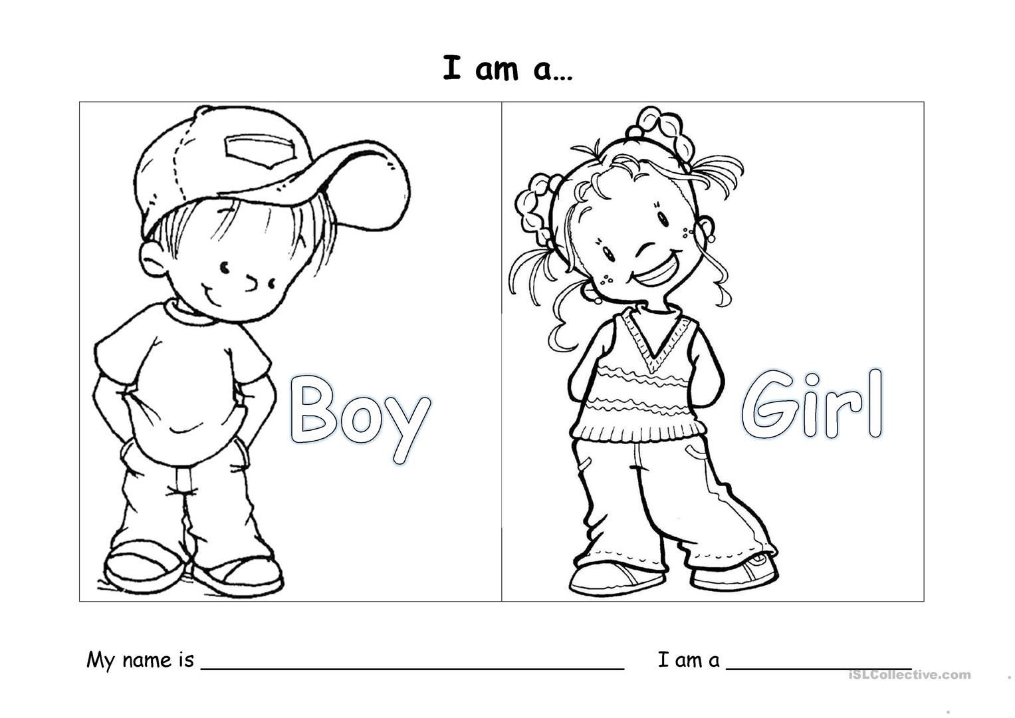
Decorate if you are boy or girl and try to write your name

